SMART LENDER: LOAN ELIGIBILITY PREDICTION SYSTEM
PROJECT-DESCRIPTION
Smart Lender is a machine learning powered loan eligibility prediction system. It uses Decision Tree, Random Forest, KNN and XGBoost to predict whether an applicant is eligible for a loan based on applicant profile, income, credit history and loan details. The best performing model is deployed in a Flask web application providing real-time predictions, reports, history tracking and batch processing.

TECHNICAL ARCHITECTURE
The Smart Lender system follows a modular machine learning pipeline. Historical loan application data is collected and preprocessed through data cleaning, missing value handling, categorical encoding, and feature transformation. The processed dataset is used to train multiple classification algorithms, including Decision Tree, Random Forest, K-Nearest Neighbors (KNN), and XGBoost (or Logistic Regression, depending on the selected model). The trained models are evaluated using metrics such as Accuracy, Precision, Recall, F1-Score, and ROC-AUC. The best-performing model is saved as a serialized model file and integrated into a Flask-based web application. During runtime, applicants submit their loan details through the user interface. The application preprocesses the input using the same pipeline, loads the trained model, predicts loan eligibility, calculates the confidence score, stores the prediction in the history database, and generates downloadable reports. The system also supports batch prediction using CSV files and provides analytical dashboards for monitoring loan approval trends and model performance.

APPLICATION MODULES
- Application: Single applicant prediction.
- Batch Prediction: CSV upload.
- History: Previous predictions.
- Reports: Analytics dashboards.
- Model: Metrics and comparison.

SYSTEM SCREENSHOTS

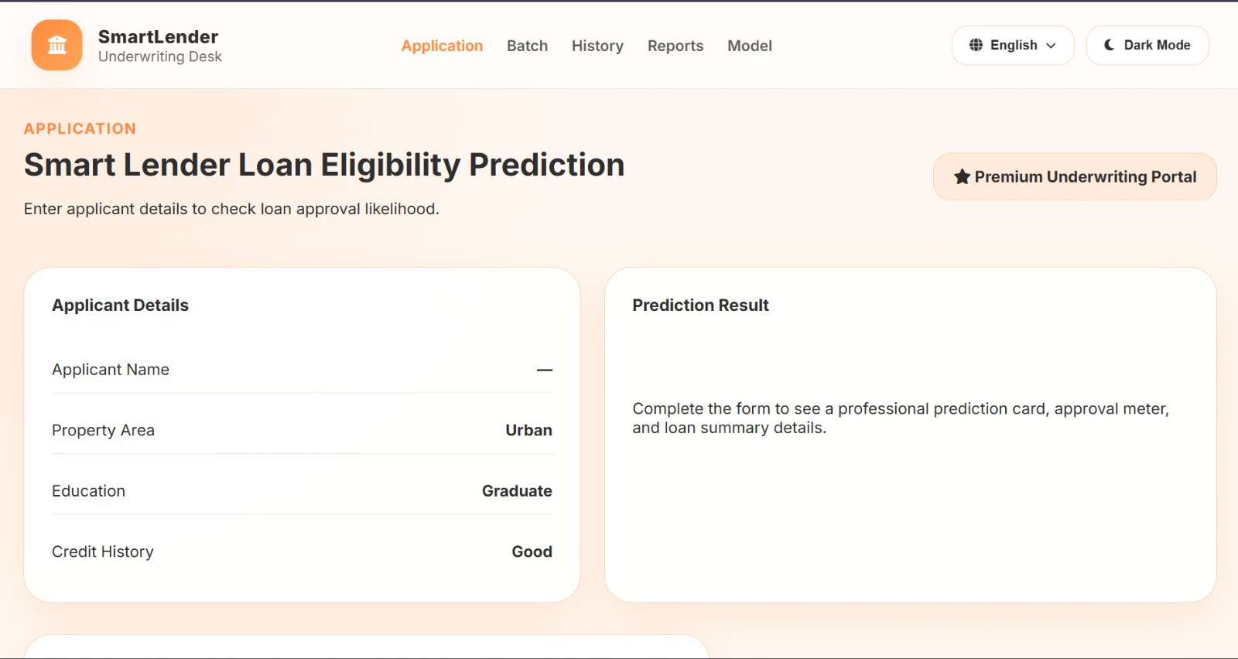
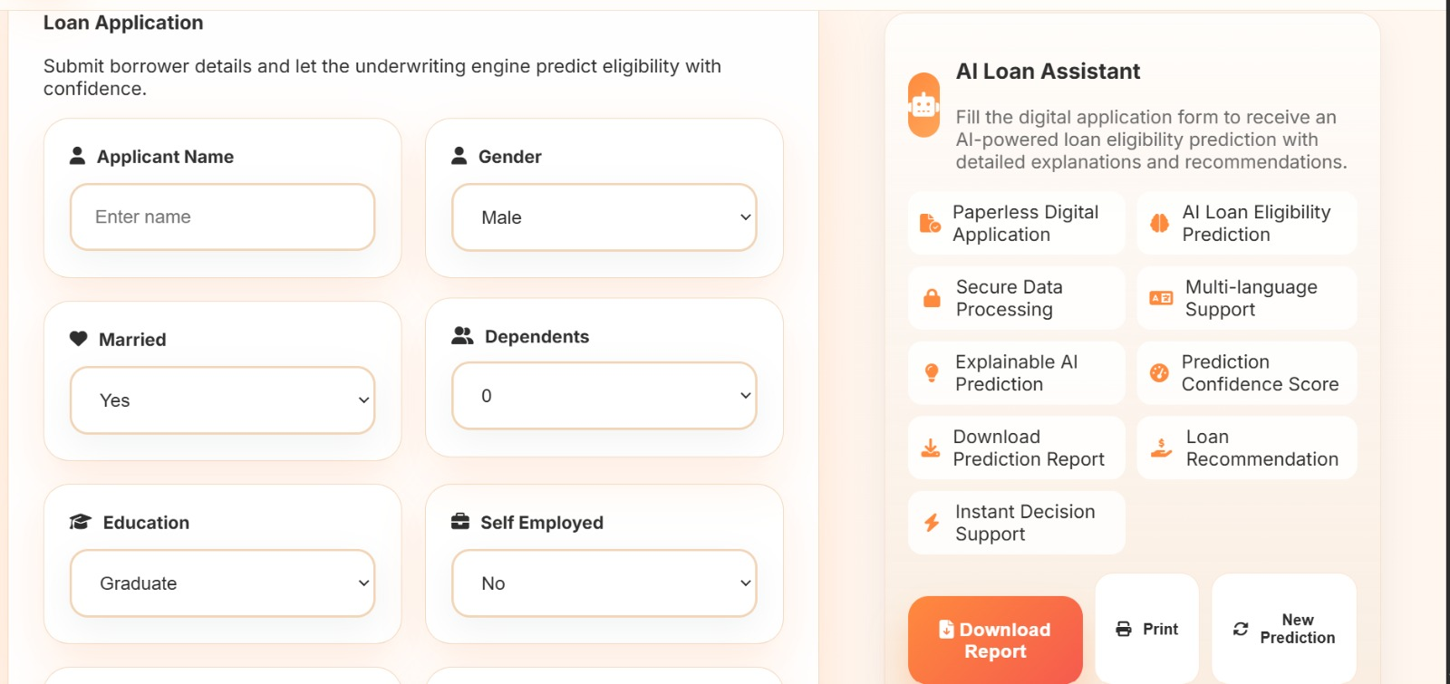
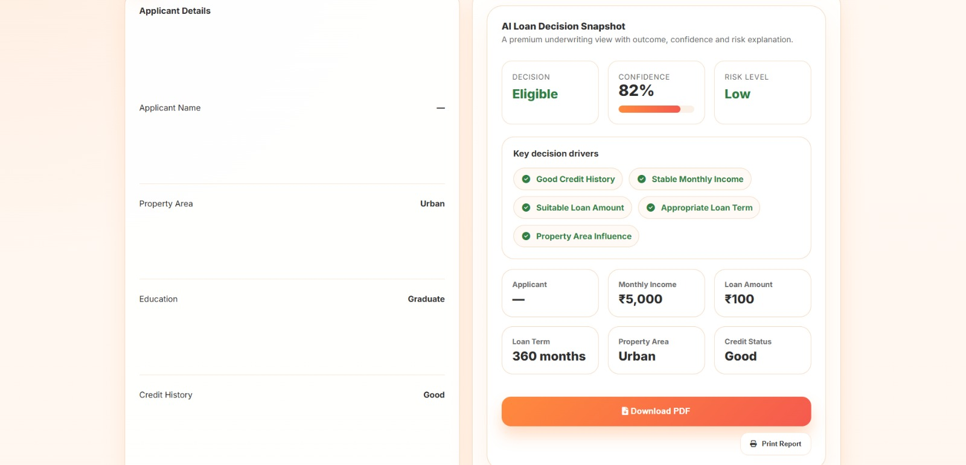
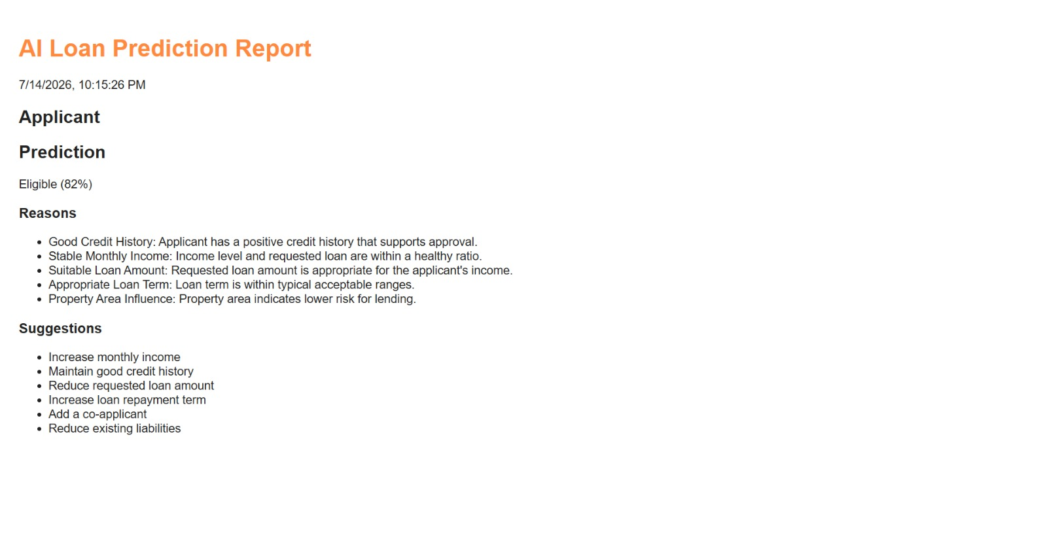
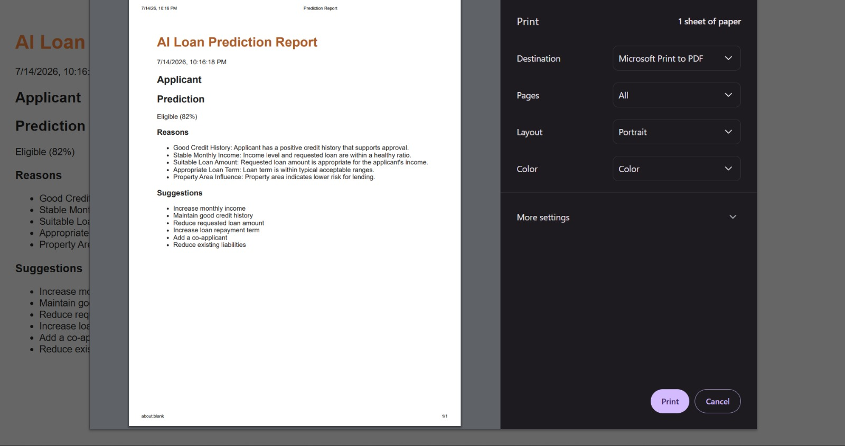
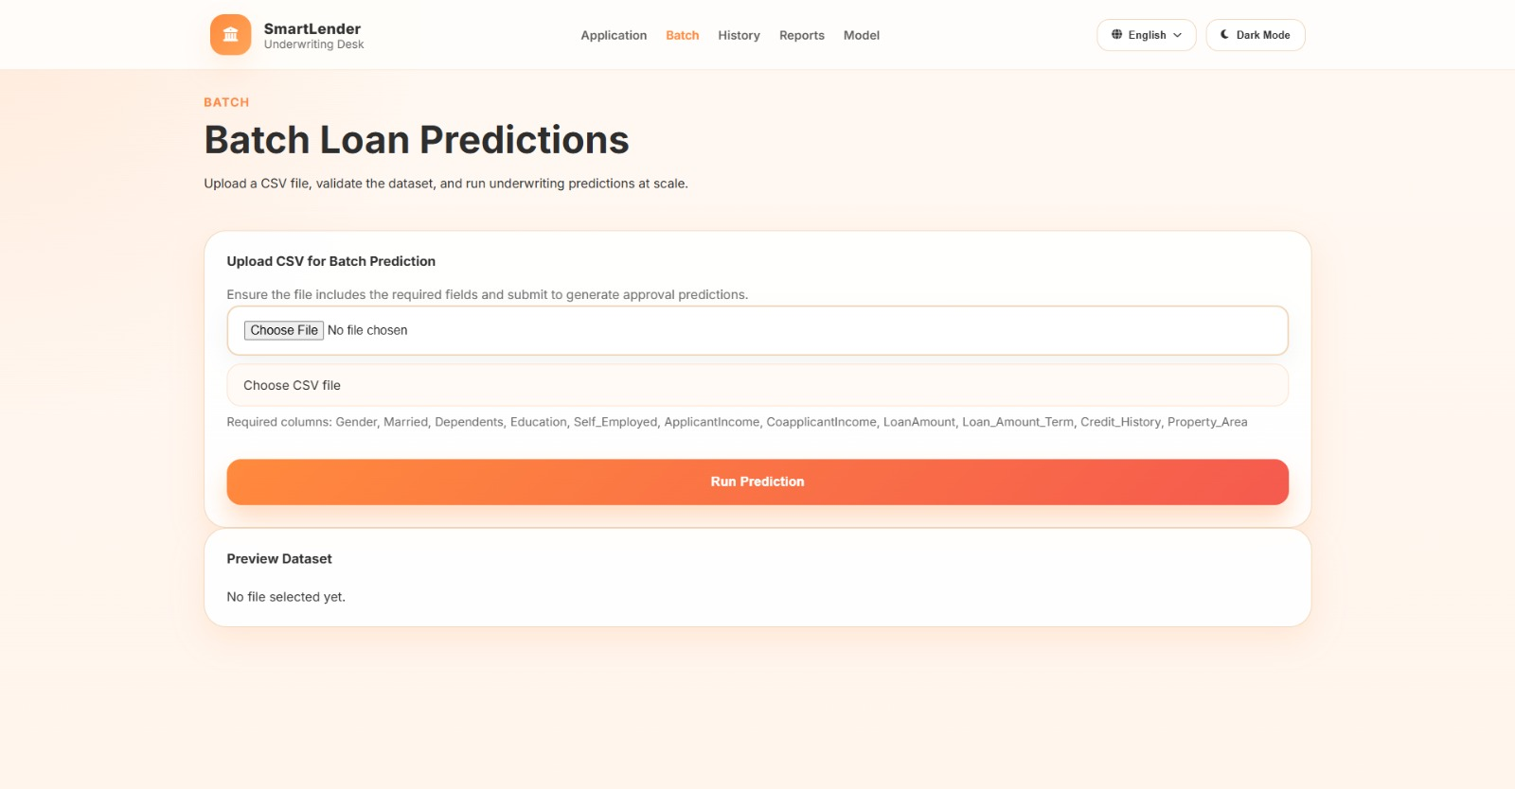
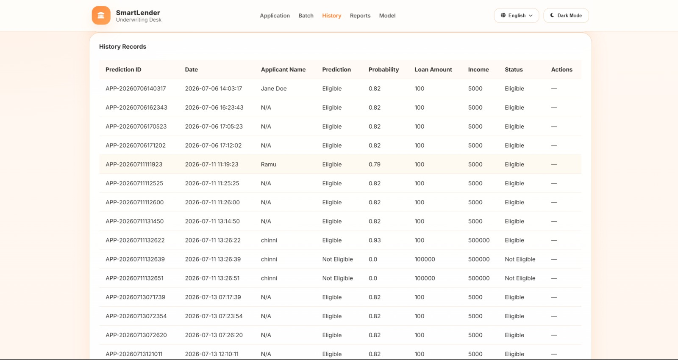
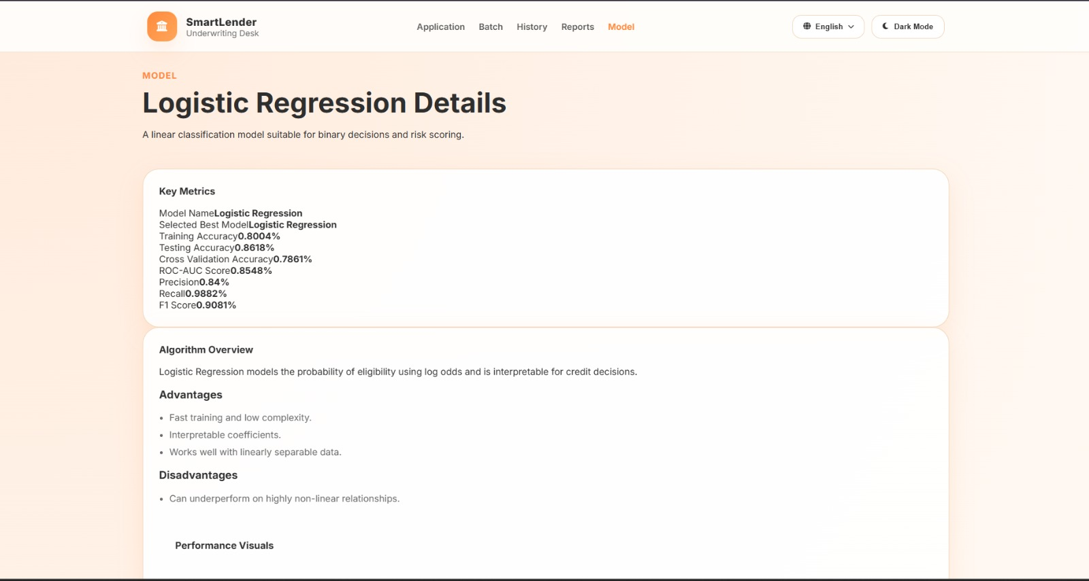
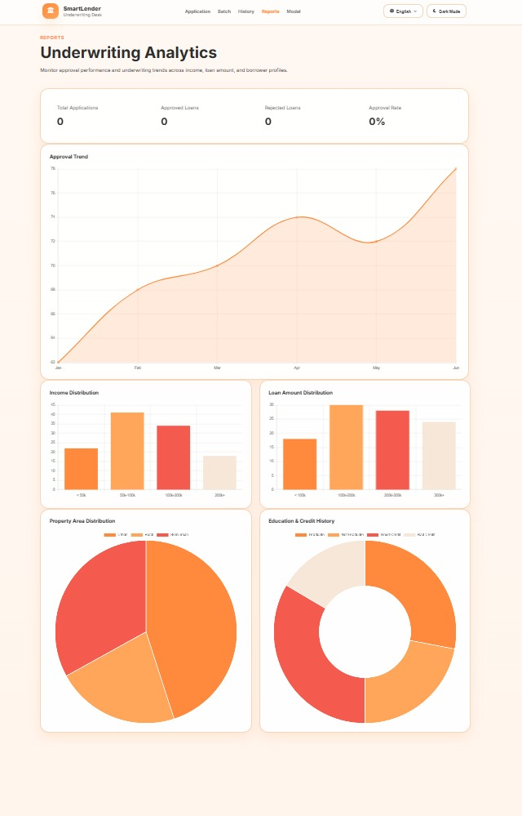


PRE-REQUISITES
Software | Version | Purpose | Official Link
Python | 3.10+ | Programming Language | https://python.org
Flask | Latest | Web Framework | https://flask.palletsprojects.com
Scikit-learn | Latest | ML Models | https://scikit-learn.org
XGBoost | Latest | Best Prediction Model | https://xgboost.ai
Pandas | Latest | Data Processing | https://pandas.pydata.org
VS Code | Latest | IDE | https://code.visualstudio.com

